1. **Introduction**

We are going to look at ShadowBall Product detail page and we are going to fix some issues it has and Redesign the Product detail page.

To find a solution, and to start redesign the Product detail we should know what Shadowball is?

**1.1 Shadowball**

Is a rugby sport manufacturing company that produce equipment for rugby but their focus is on an innovation ball they have produce, that give Rugby athletes and kids possibilities to develop their skills to throw and catch the ball, The best part with the ball is that you don’t need a partner. And that something rugby sport have been missing. If you compared to soccer you have been having the chance to develop technical skills on your own, as long the soccer ball has been developed.

The variety of the people that will be using the website of various reasons buying for themselves, gift, etc. To figure out users main goals and concerns are.

More about Shadowball : ([**https://youtu.be/ljlypP1UI5w**](https://youtu.be/ljlypP1UI5w)& [**https://shadowball.co.za/**](https://shadowball.co.za/)**)**

1. **Business Goal**

It can be important to get their communication thru opinion leader, that have good influence on their target community.

**2.1 Primary Goal**

Sell more rugby balls, Try too Optimize our page for better conversion rates. ([**https://shadowball.co.za/**](https://shadowball.co.za/)**)**

**2.2 Secondary Goal**

Developing rugby skills at grass roots level. Travel around in form of training roadshow where primary and High schools are visited by SpringBok Players and trainers.(Manny: lesson 2,week1) <https://nashuarugbyskillsproject.co.za/>

**3.0 Quantitative data**

**3.1 who are our users**

* Primary age group:Aged between 25-34
* Secondary age group : 35-44
* Female users 43.1%
* Male 56,9
* Moms and Dads
* Kids

**3.2 Category of users**

1. Shoppers/Value Shoppers - 3.06%
2. Sports & Fitness/Health & Fitness Buffs - 2.70%
3. Media & Entertainment/Movie Lovers - 2.48%

**3.3 What are their goals**

* Buy a rugby ball
* Skills development
* Fitness awareness and improvement

**3.4 What are their(users) motivations**

* Mom and dad's point of view is to buy their child a rugby ball.
* From a child's point of view it is to increase their skills as a rugby player and practice rugby drills.(Manny week1)

**4.0 Behavior**

Product detail page

<https://shadowball.co.za/product/shadowball-pass-booster-program-pack-size-4/>

* Clicking on Image “Carousel”
* Users are clicking on the buy now products more than they should instead of buy now
* No users are clicking on the share icons.
* Newsletter signup box no one is clicking on it.
* Users clicking the back to top button A LOT.
* Related Products component… kinda useful,  but only the flag ship product is being clicked.
* International distribution in footer gets clicks - 1.2% (Manny week1)

**5.0 Qualitative analyze**

Too start with I did observe my fellow student and how he did spend his time on the page, we did also have a discussion where we did use post-it too explain every step you need to do to click to buy a item. The conclusion is listed down here

* Too many clicks to checkout.
* Pages too long, too much scrolling
* Buy now buttons call to actions are hidden from view the CTA should be above the fold.
* Initial photo is too large.
* Mini cart icon is missing in header

**6.0 Competitor analysis**

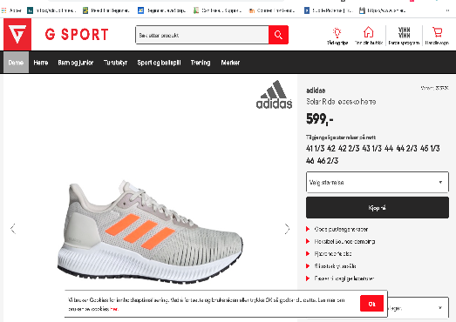



* Brand Name



* Price



* Size Available



* Rotation of the image



* Zoom possibilities on the image



* Rotation possibilities on the image



* Summary of the shoes benefit



* Tell you info about what kind of shoes it is



* Id nummer



**7.0 User Personas**

**7.1 Demographic**

* **Nam:** Elizabeth
* **Age Group:** 27-40
* **Position:** Mom

**7.2 Tech comfort**

* **Pc :** Medium Level
* **Web:** Good

**7.3 Personal Background**

* High educated, teach in university level

**7.4 Needs**

* Solution for the kid to have a chance to practice on his own.
* Skills developing for the kid
* Don’t have time to drive the kid to practice every day and this product give the child possibility to train where and whenever the kids want.

**7.5 Motivation**

* Her kid to be better in rugby than the neighbored kids

**7.6. Scenarios**

* knowledge about how to develop rugby skills

**8.0 Paper Prototype**

Didn’t find the image I did take in the class. But the reason is to communicate ideas between designers, devolper, users and other stakeholders in the first stages of the user-centered design process.

It can also be used as testing technique to observe the human interaction with user interfaces even before the interfaces are designed and developed.

Short summary of keynotes of this method

* User involvement at early stage
* Cost-effective
* Encourages creativity
* No design or coding skills needed

**9.0 Conclusion**

We have been learning that interaction design is focusing on the moment of interaction between a human and in our case a display. Thru a lot of difference working process we have done in the lecture give us possibility to use technologies to make a smooth process for the human and put them in the first line for developing a website.

I did also learn that that different websites will attract different users, that also will have different goal. We use different tools to figure this out like quantitative and qualitative research. We did also get a small view of what information we can get hold on thru instruments like Google Analytics and Hotjar.

Once we did complete our research into the user, we did make personas. The reason was to be being able to communicate the various goals and etc. it’s a realistic abstraction of a user.

Because the time limit, we did just make one.

We did also make a storyboard to get a clear vision of what we are excepting our user will react, reason for that was to involve everybody in the process and try to understand users motivation, goal .

**10.0 Reference and attachments**

**10.1 Reference**

* Interaction design
* Manny
* <https://themwebs.me/client_area/sarto_mass_services/wireframes/02.html>
* <https://docs.google.com/document/d/1WP_DgDMUsD6woOFI8lv1TgCZiAT7vfEZdbjr8wx8GAA/edit?ts=5e567eaf>
* <https://usabilitygeek.com/paper-prototyping-as-a-usability-testing-technique/>

**10.2 attachments**

